**Work Report of The Actors Brand**

**YouTube SEO and Thumbnail Design**

**Start : 10/10/2024**

**End : 20/11/2024**

**1.** Film Industry Jobs Explained in 2024 | Career Opportunities In Film 🎬

**Before SEO Score :**

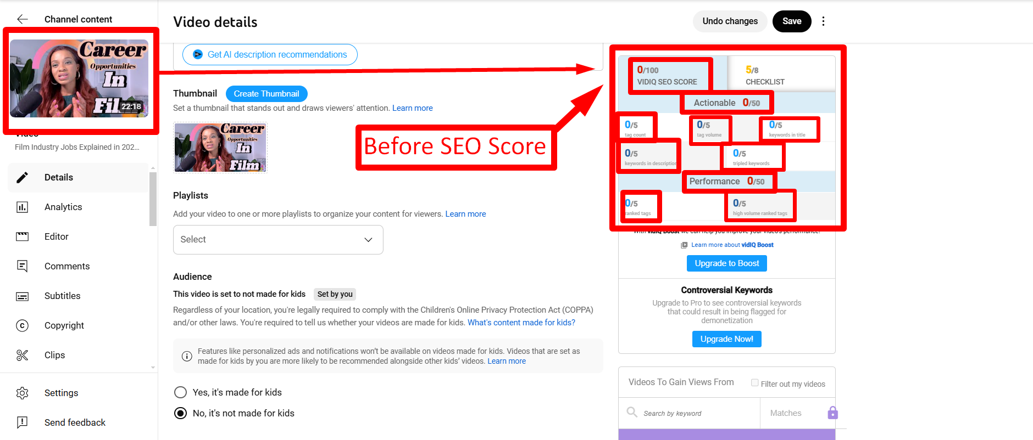

**Updated SEO Score :**

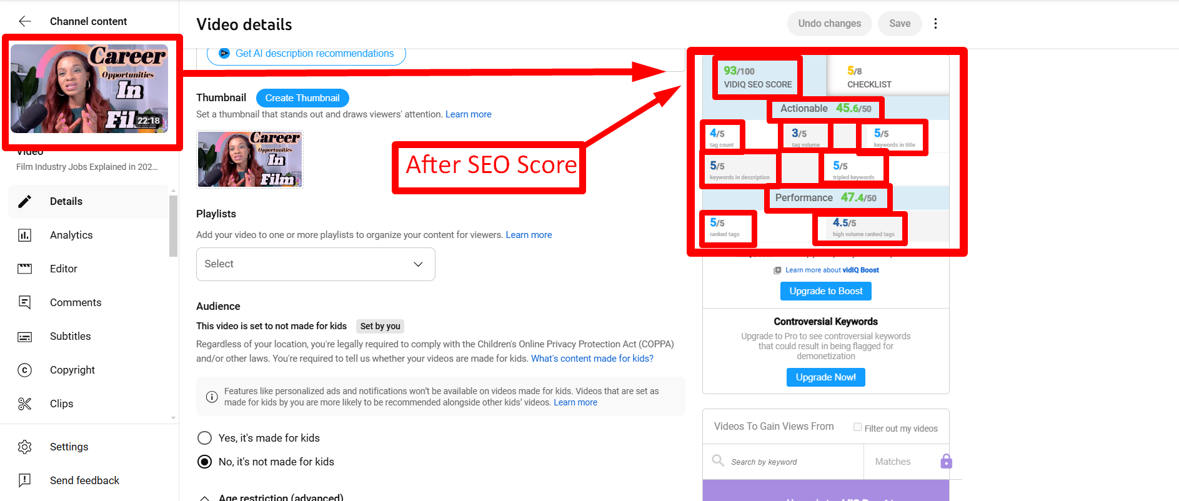

**Video views (Before and After):**

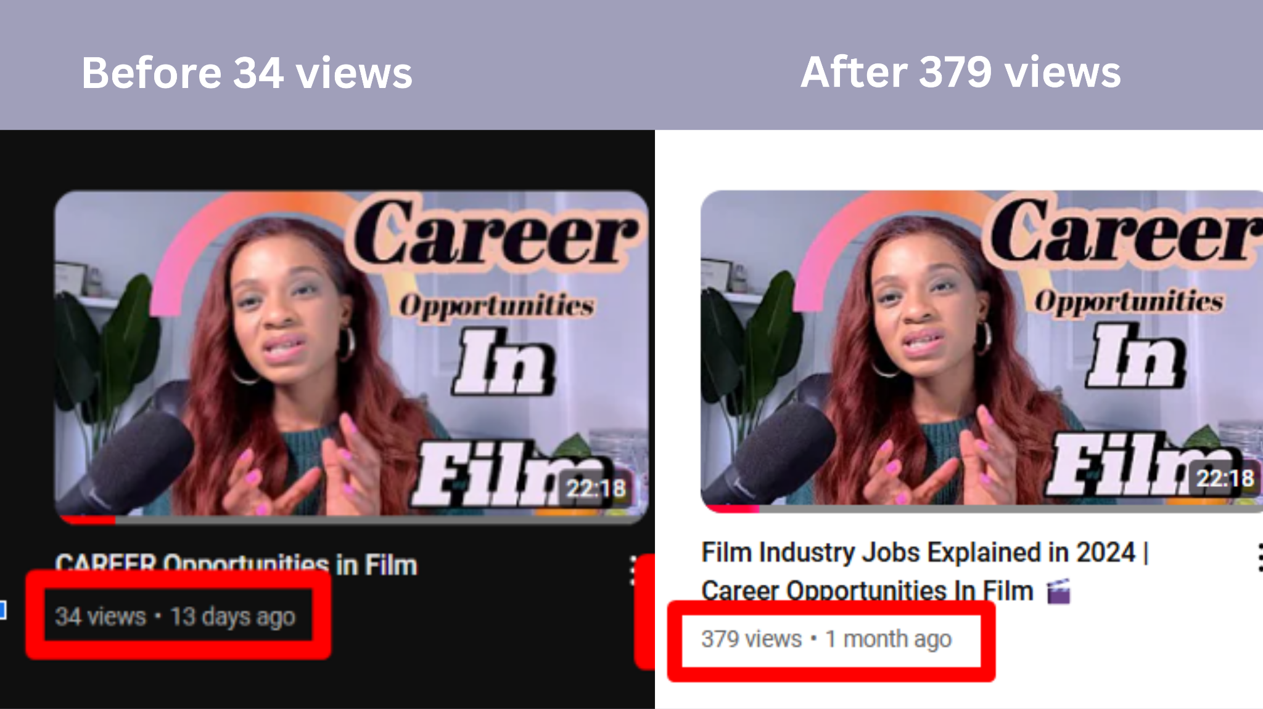

**2.Actors Beware of Scams ! Tips to avoid actor scam in 2024**

**Before SEO Score :**

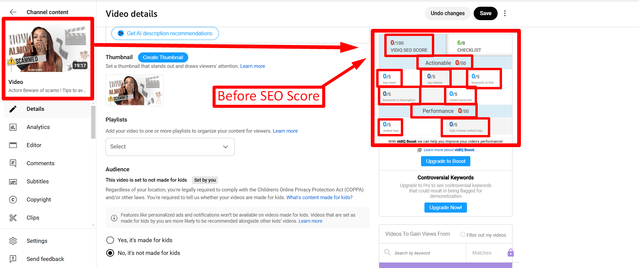

**After SEO Score:**

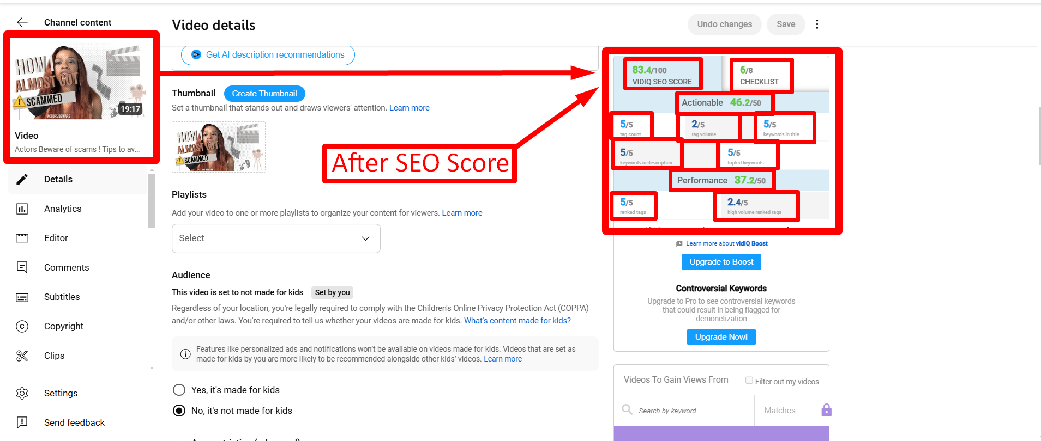

**Video Views (Before and After) :**

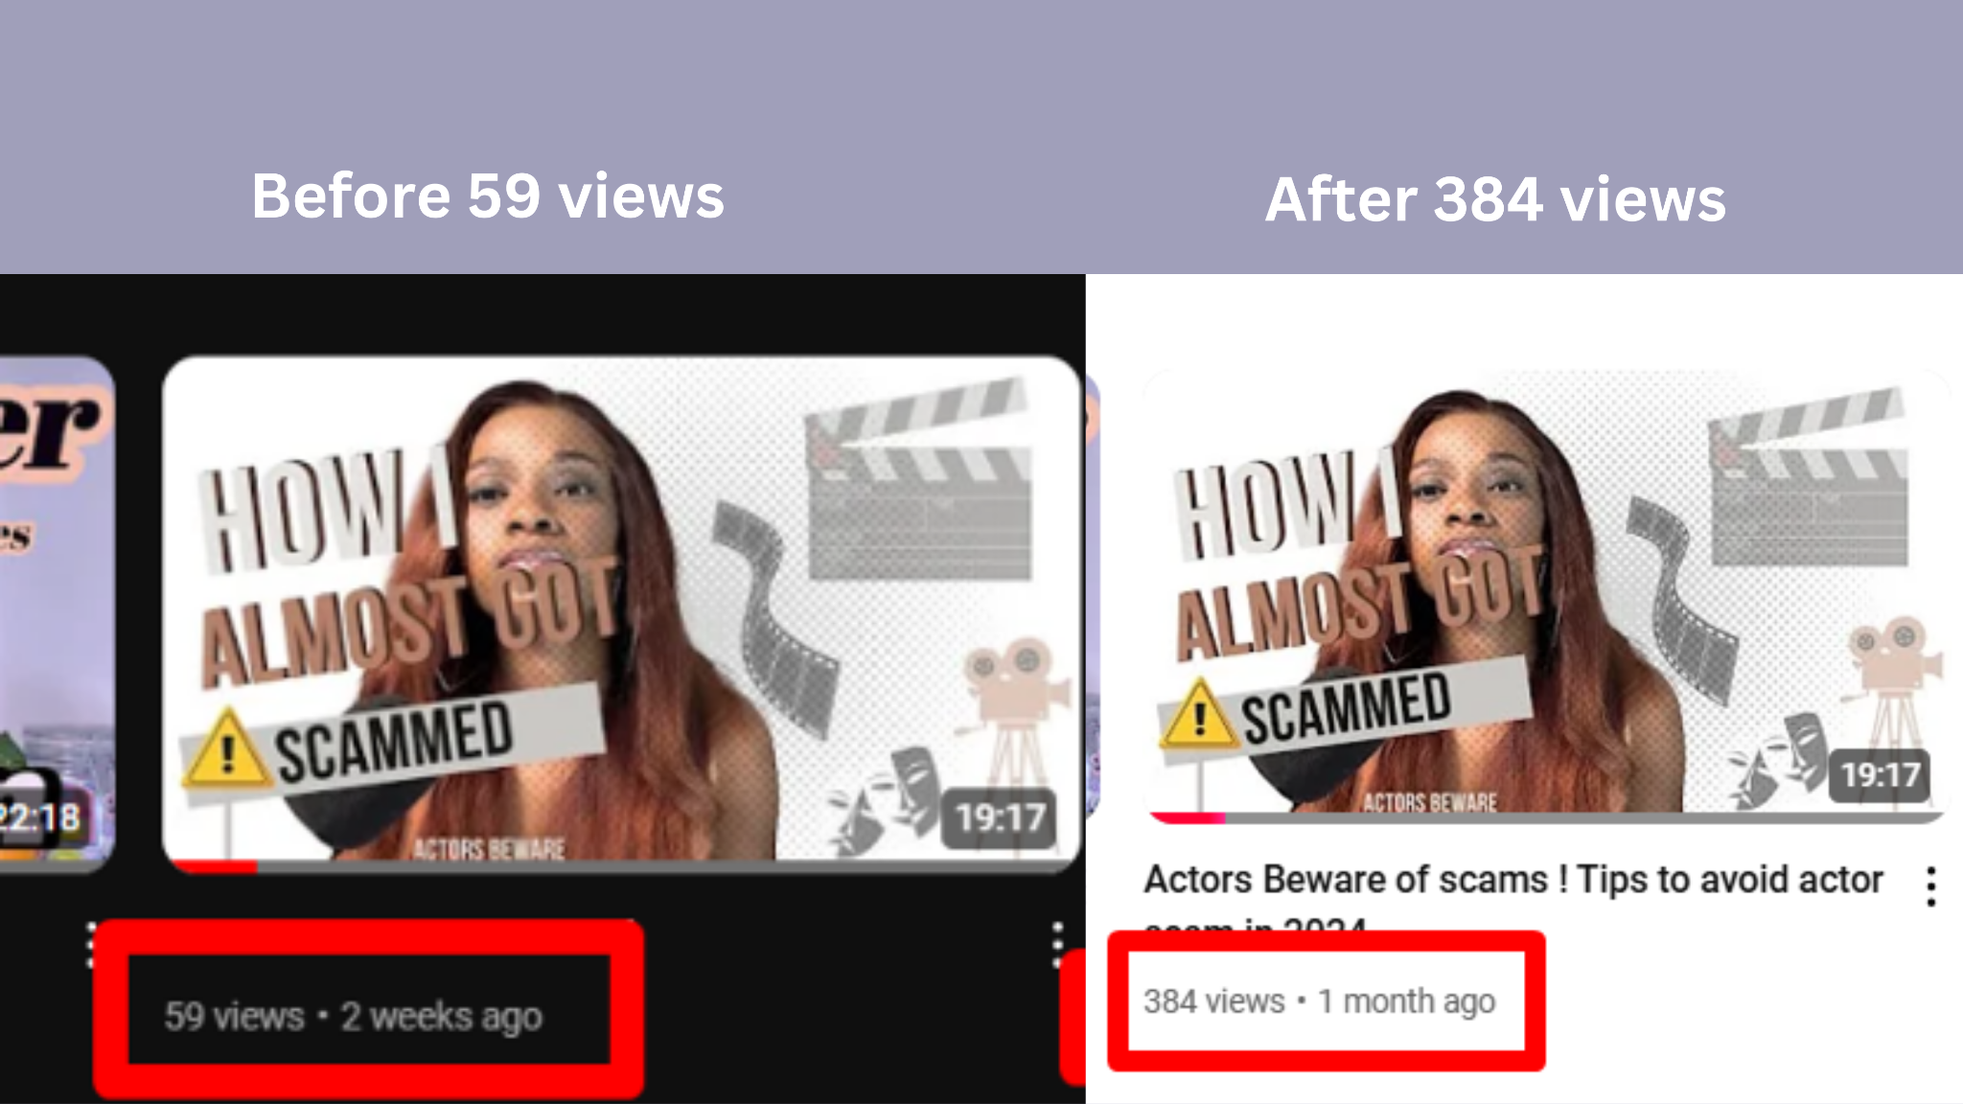

**3.** Career management for artists | Who is a better representative?

**Before SEO Score :**

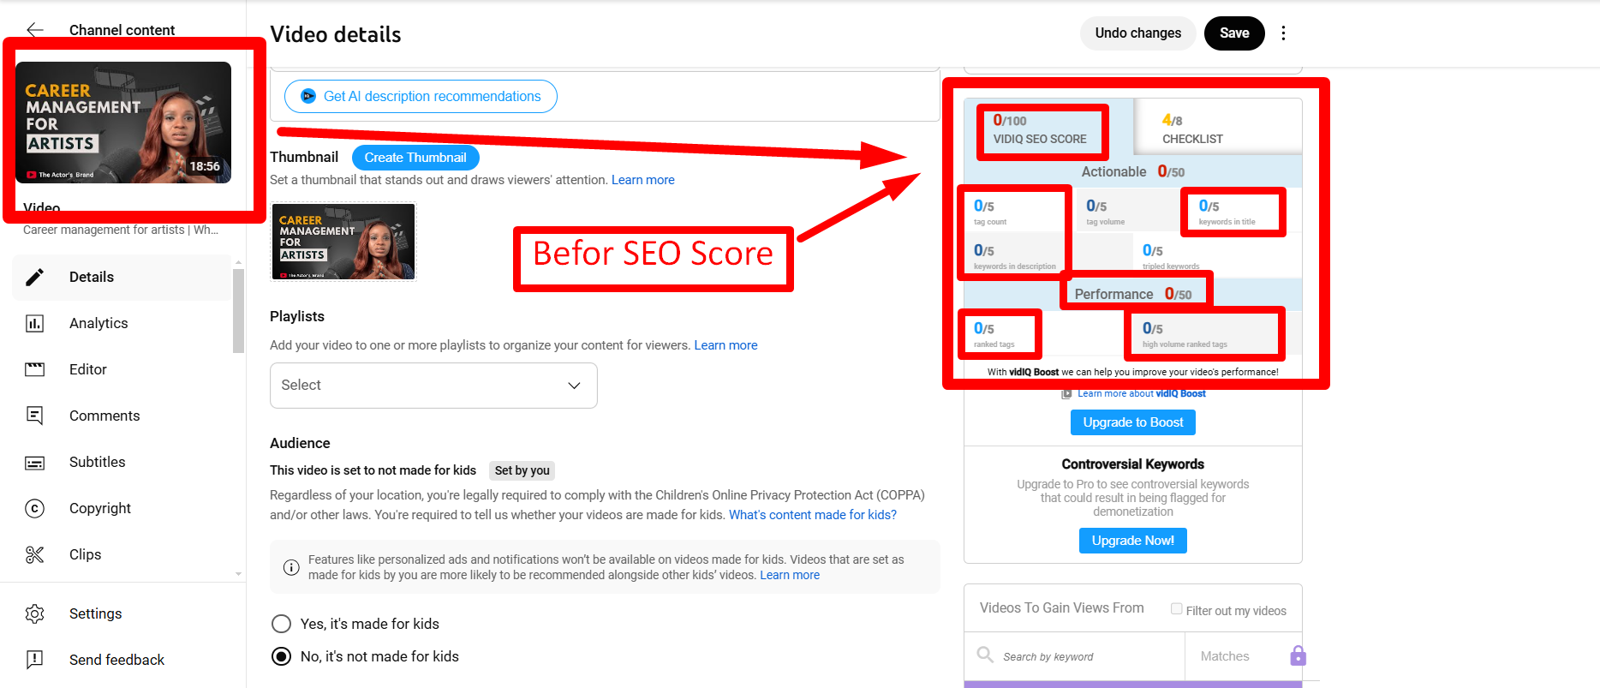

**Updated SEO Score:  
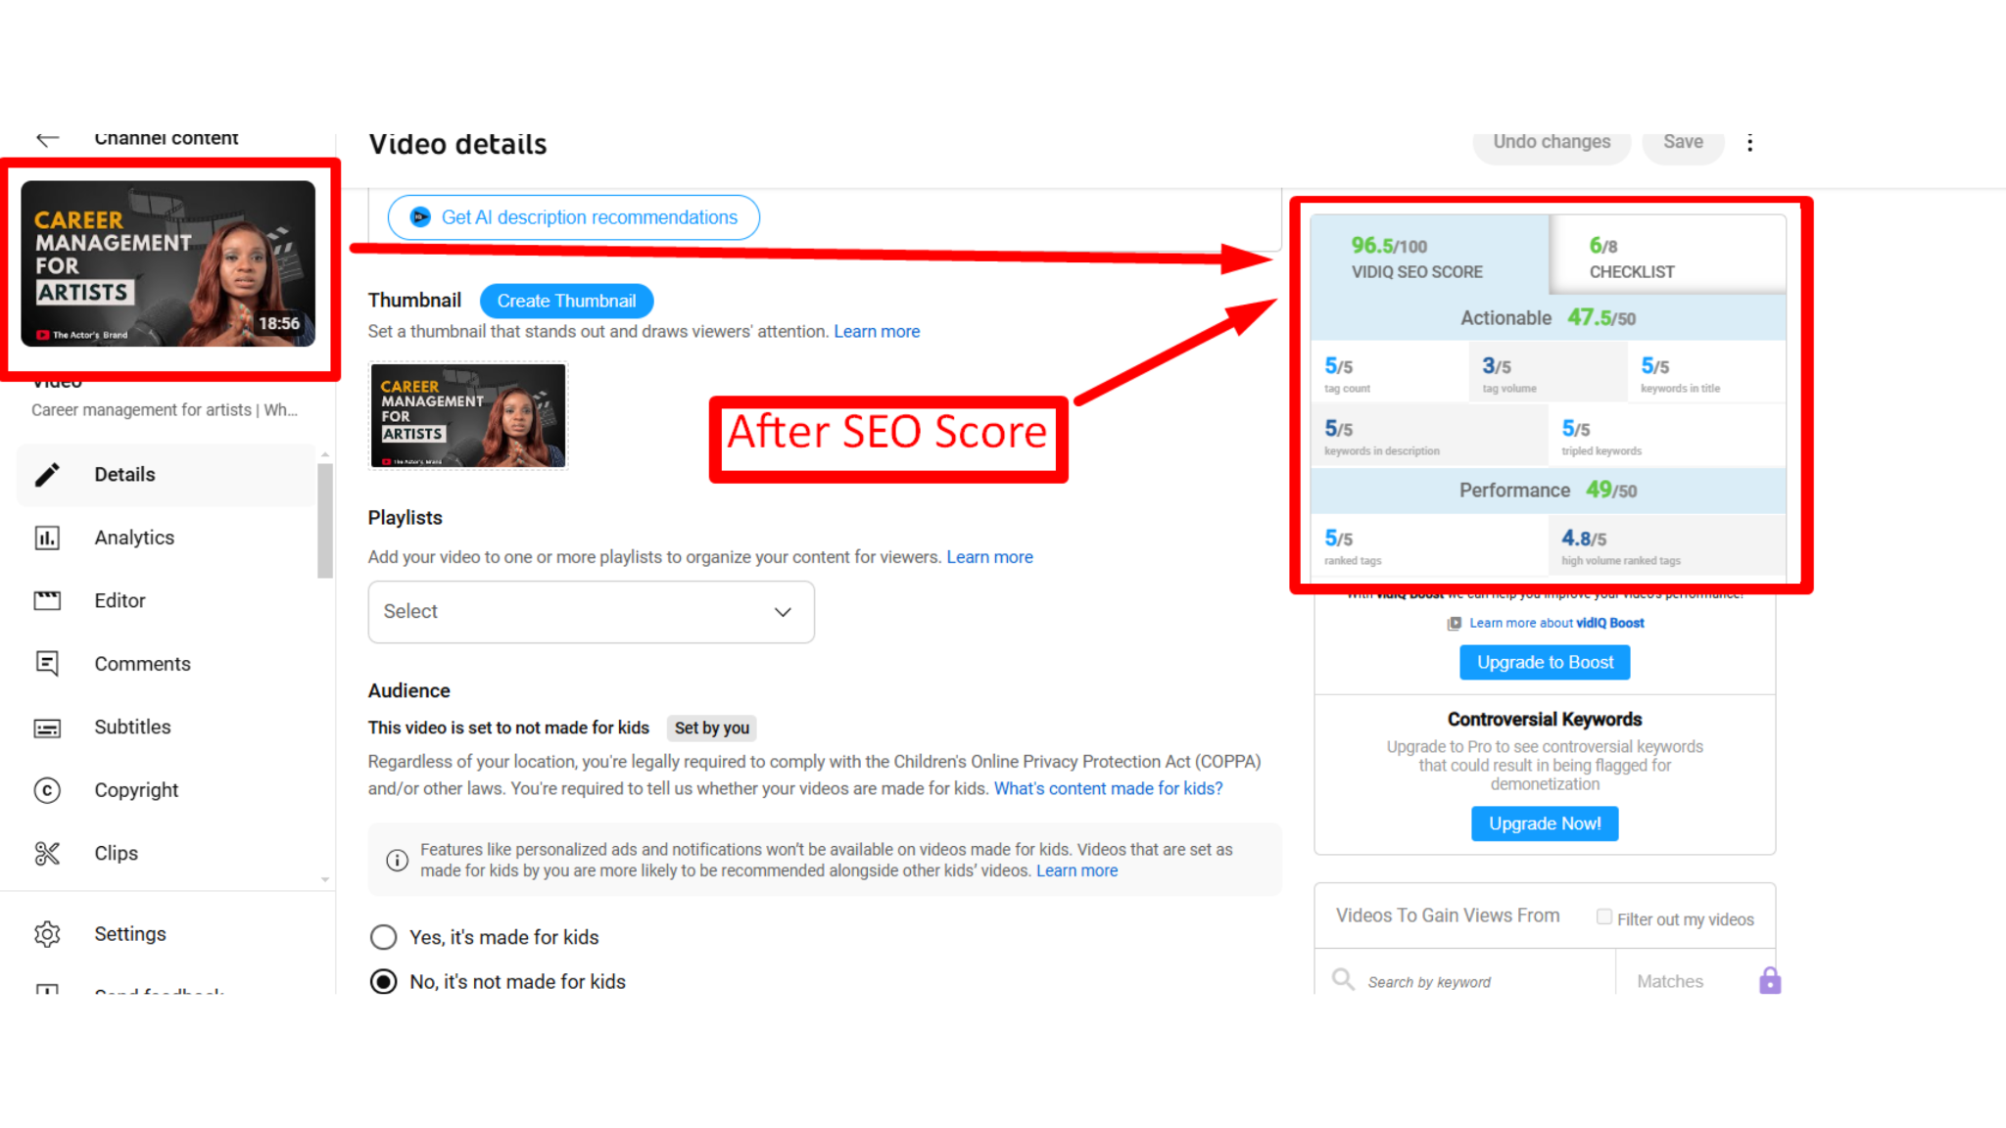**

**Video Views (Before and After) :**

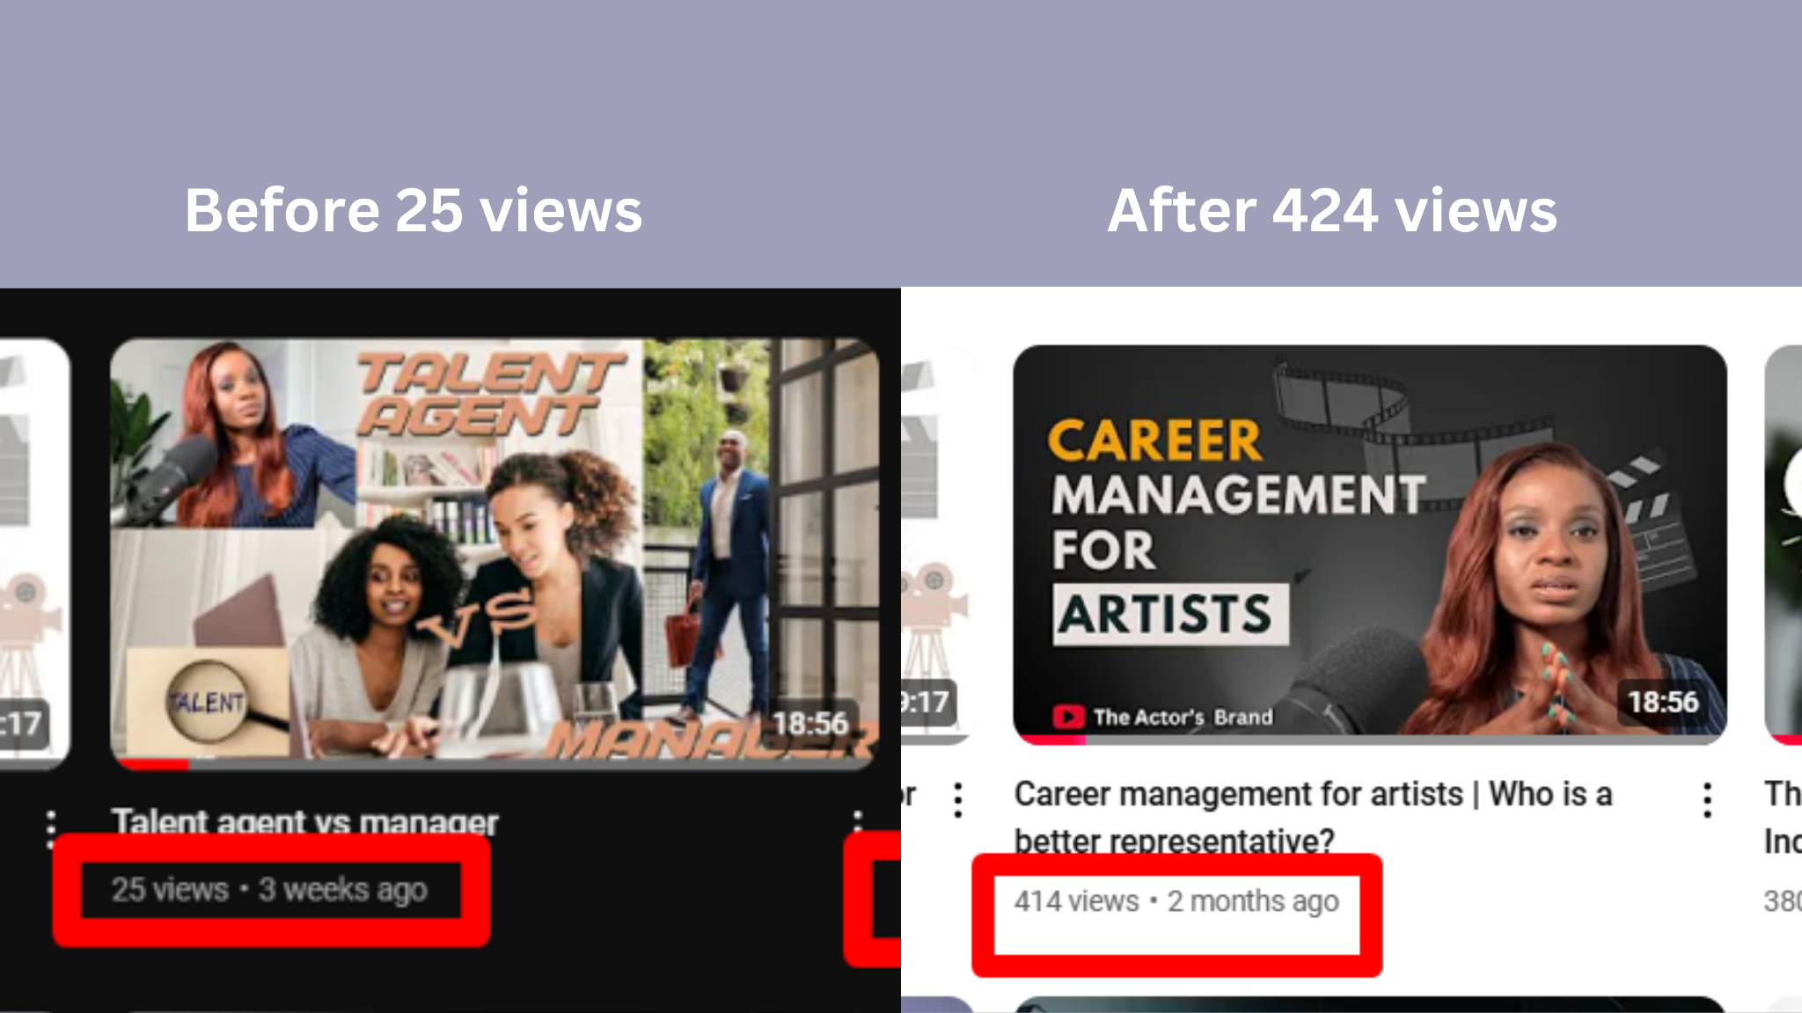

**4.** The Real Challenges Actors Face in Film Industry | Film Industry Tips

**Before SEO Score :**

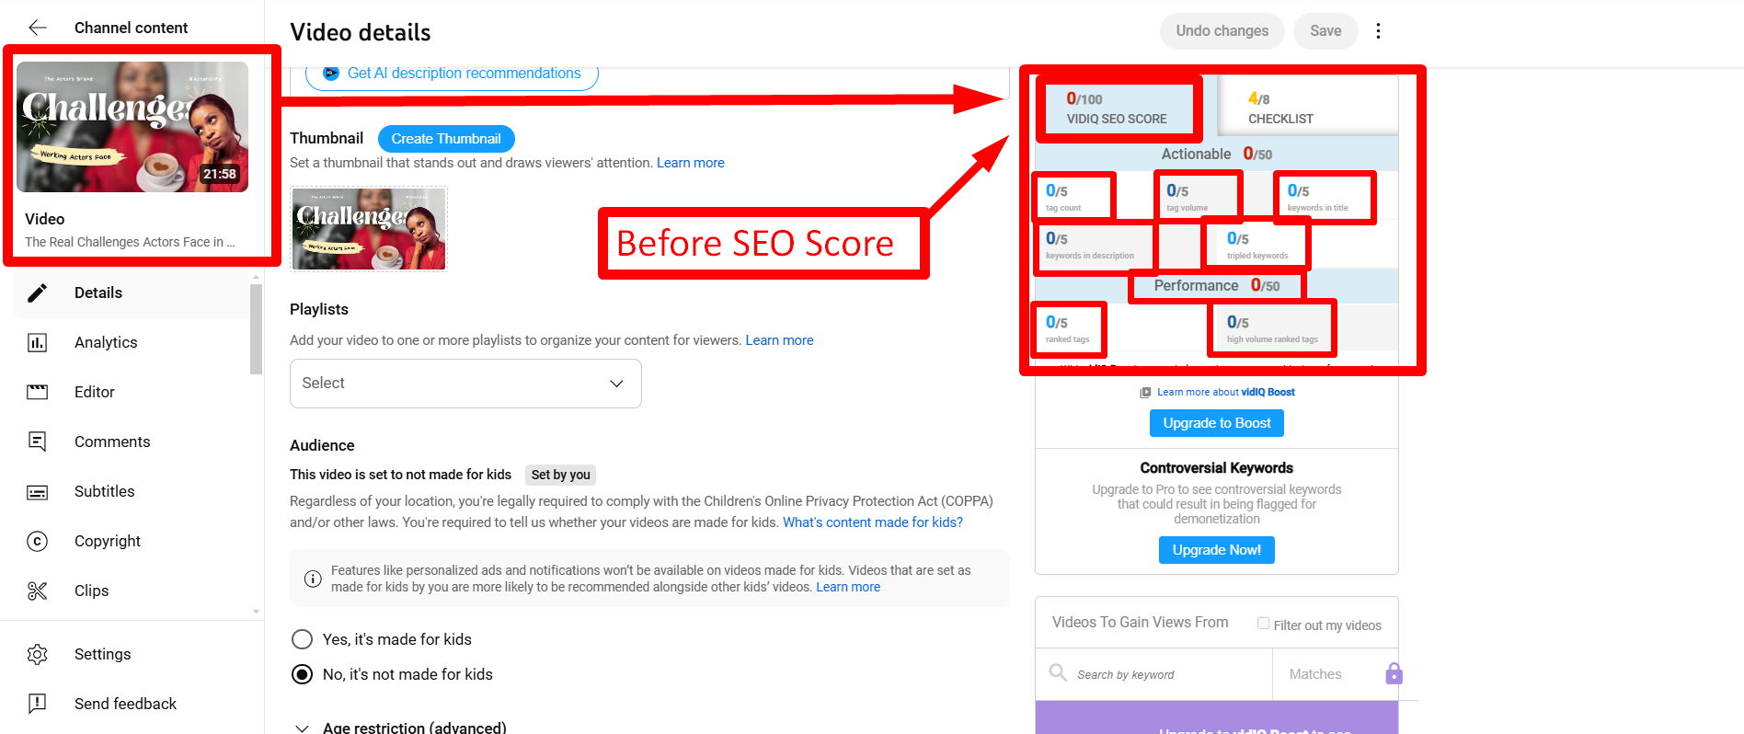

**Updated SEO Score :**

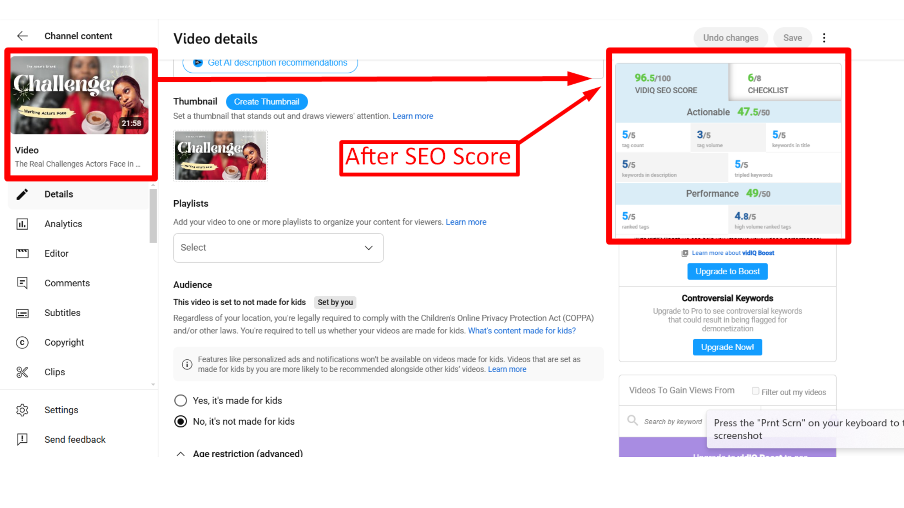

**Video views (before and after) :**

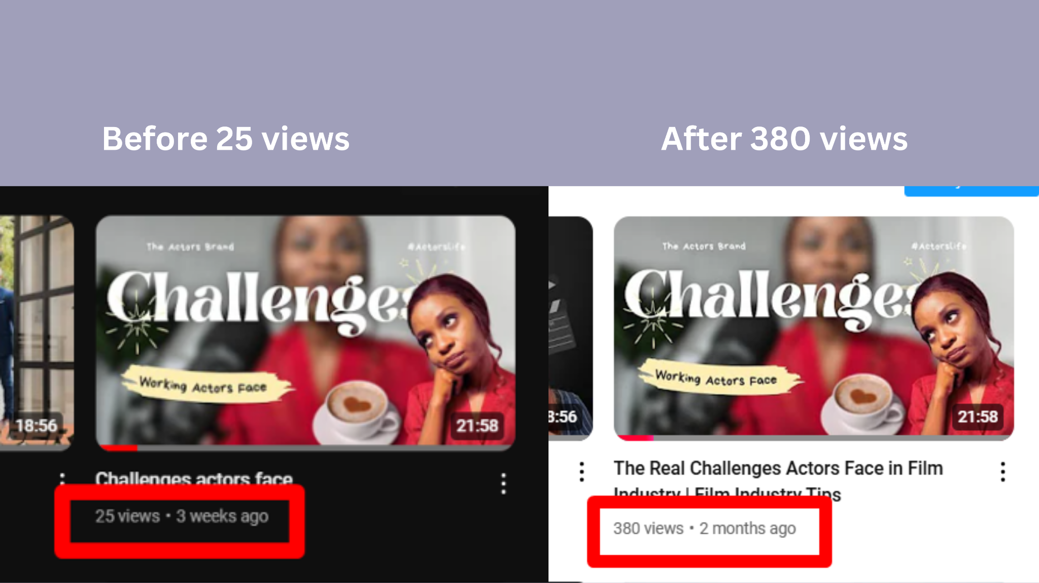

**5.** How to Break Down a Script | Part 2 | Film Industry Tips

**Before SEO Score :**

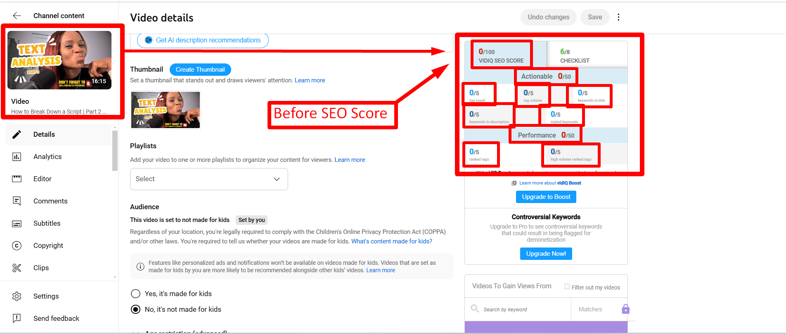

**Updated SEO Score :**

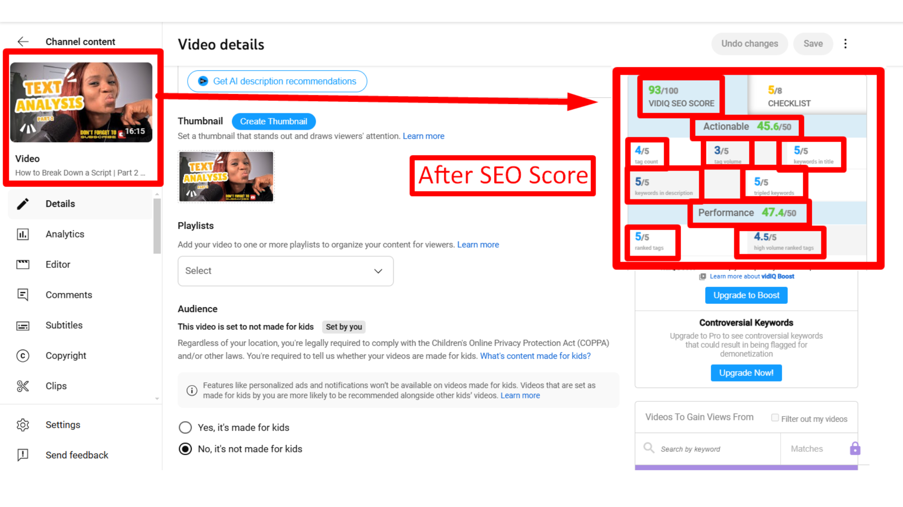

**6.** How to Break Down a Script | Part 1 | Film Industry Tips

**Before SEO Score :**

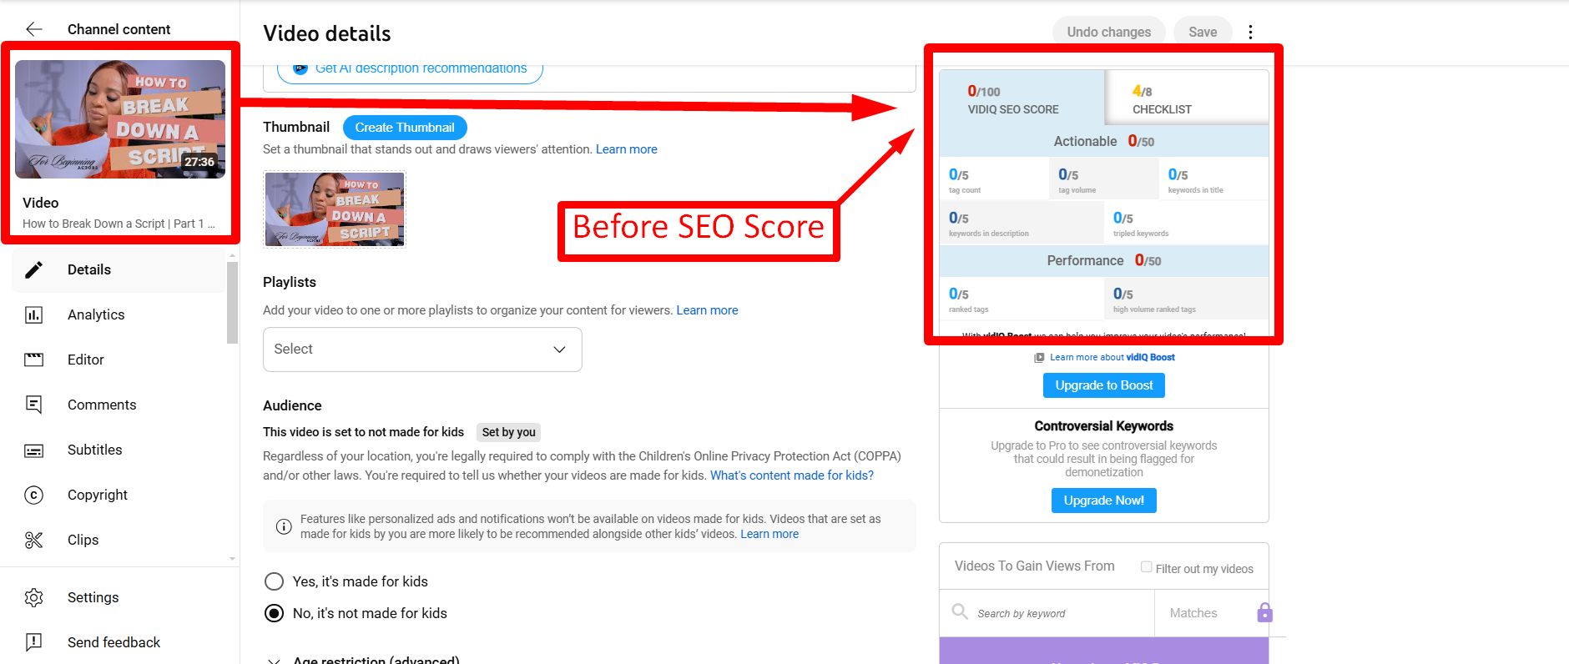

**After SEO Score :**

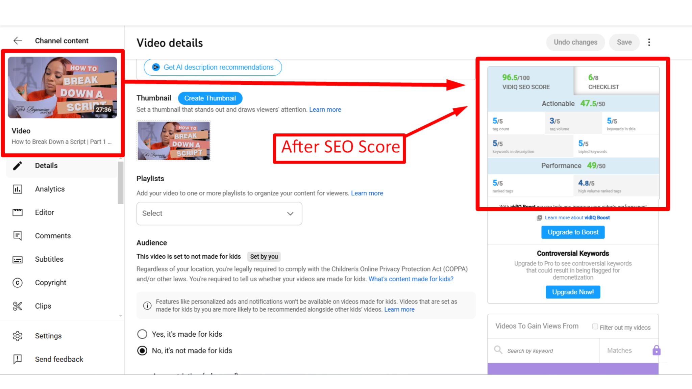

**Video views ( Before and After) :**

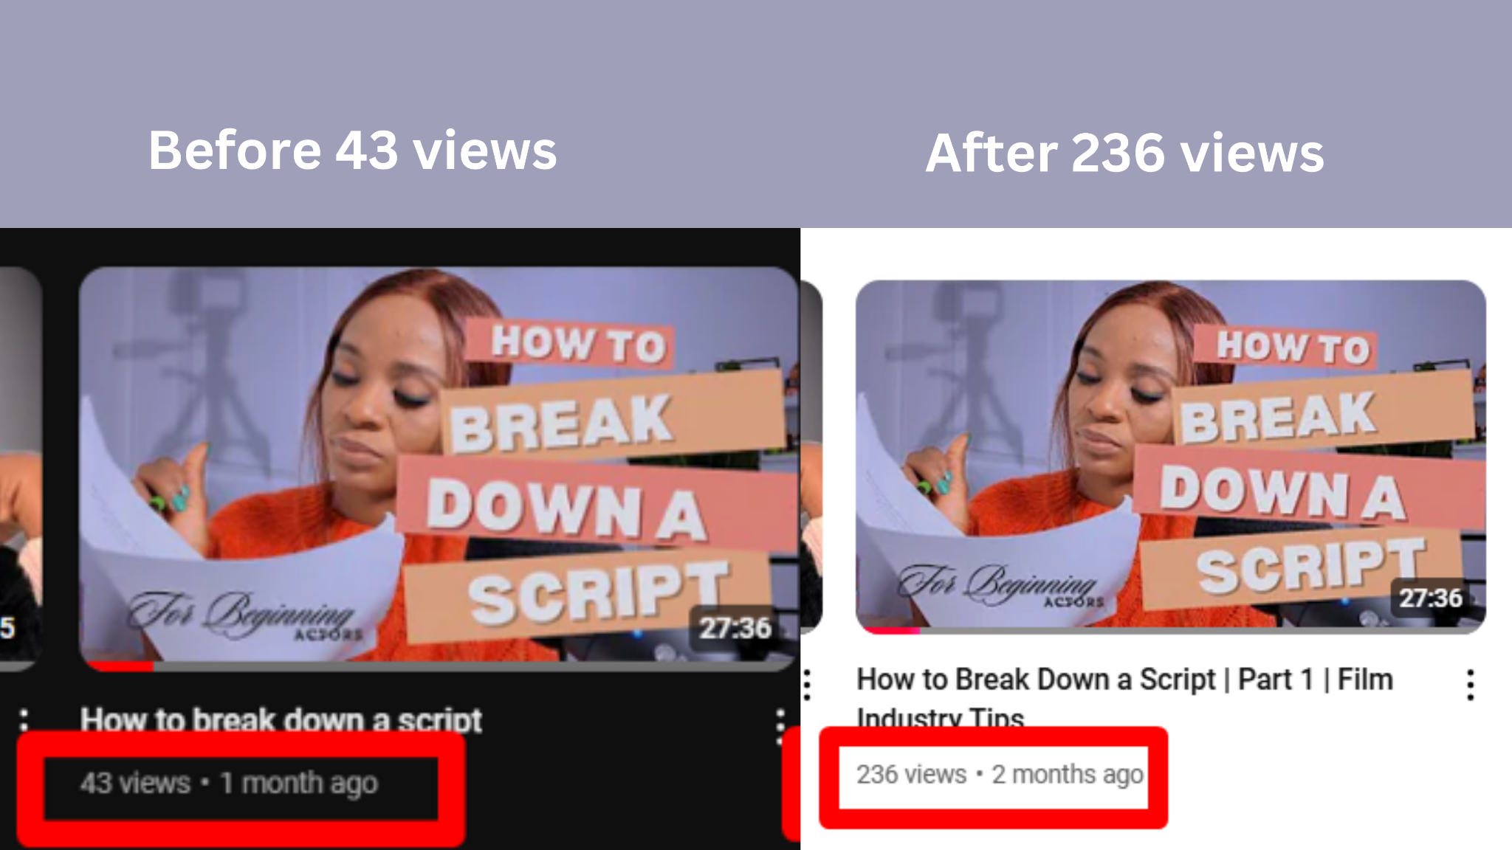

**7.** Film School vs Raw Talent | What Really Makes a Great Filmmaker?

**Before SEO Score :**

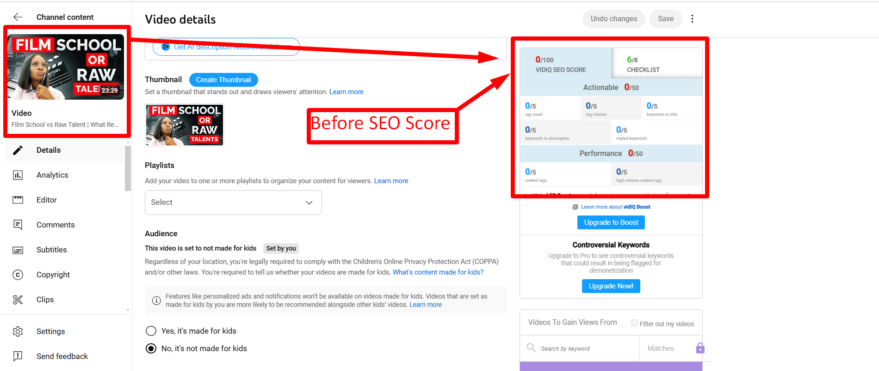

**After SEO Score :**

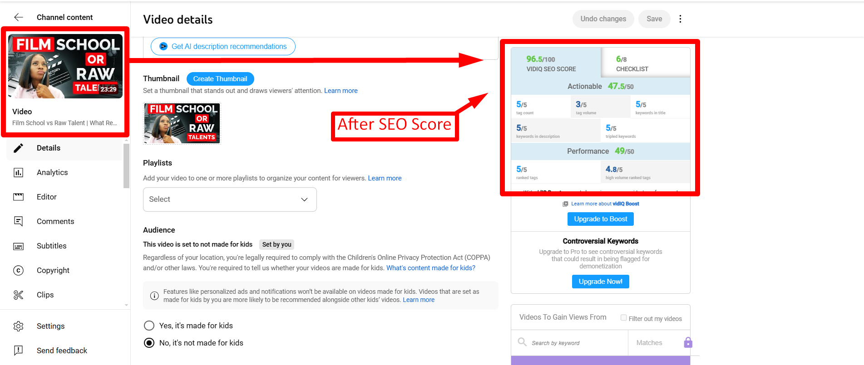

**Video views (Before and After) :**

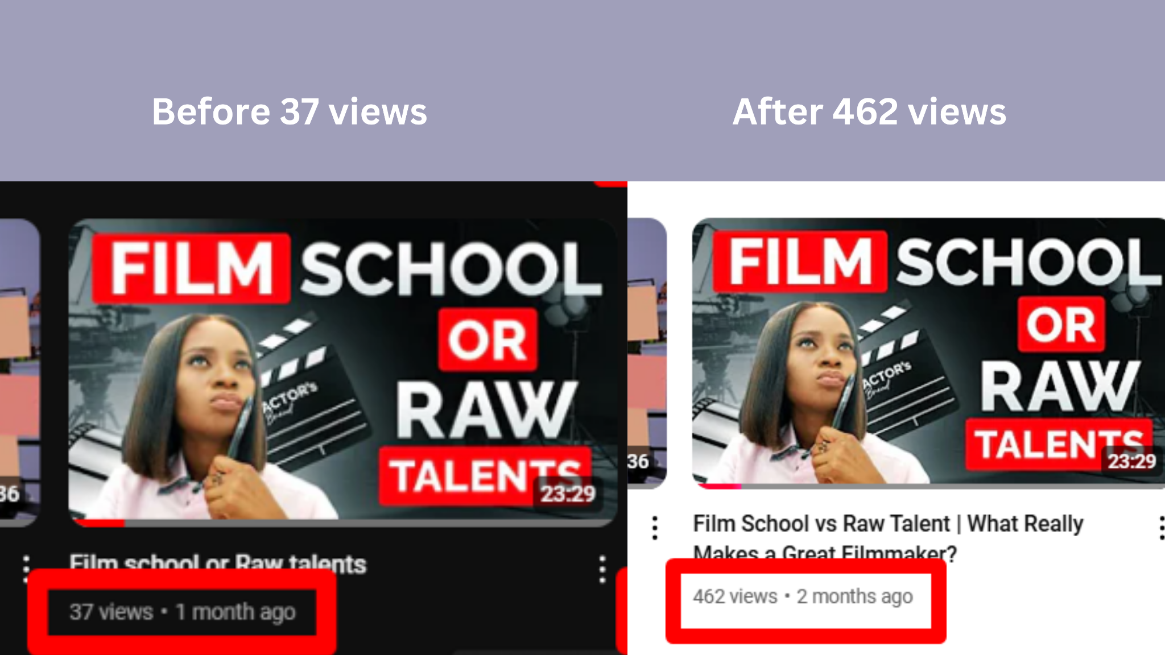

**8.** The Audition Experience in Film Industry 2024 | Nervous to confident

**Before SEO Score :**

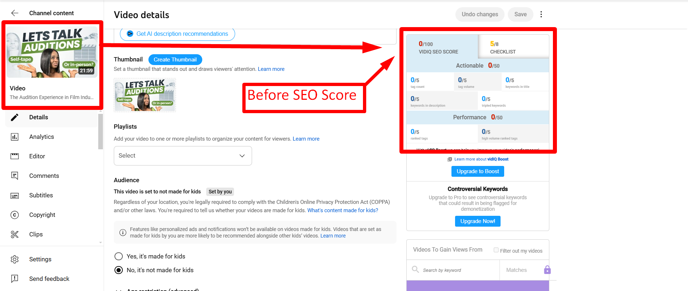

**After SEO Score :**

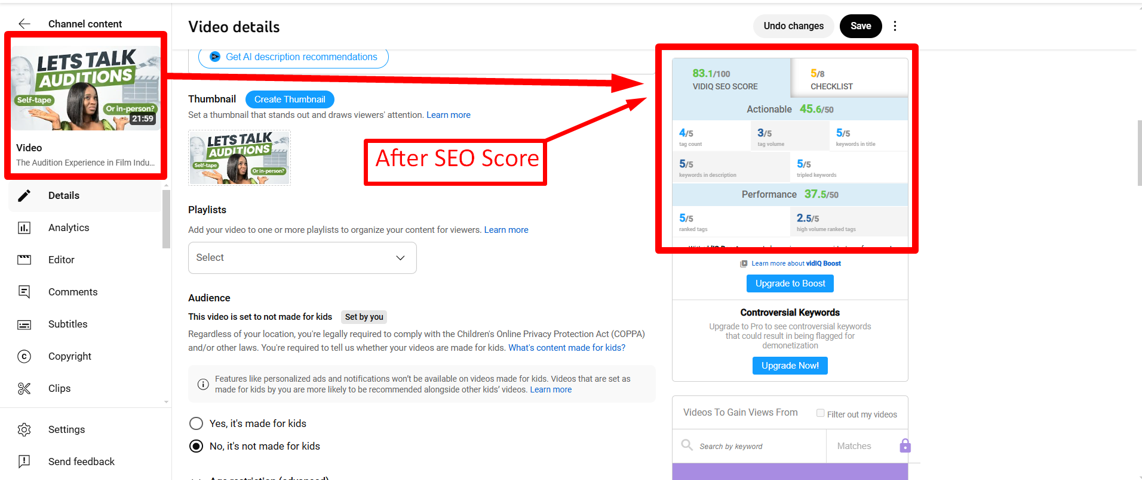

**Video Views ( Before and After) :**

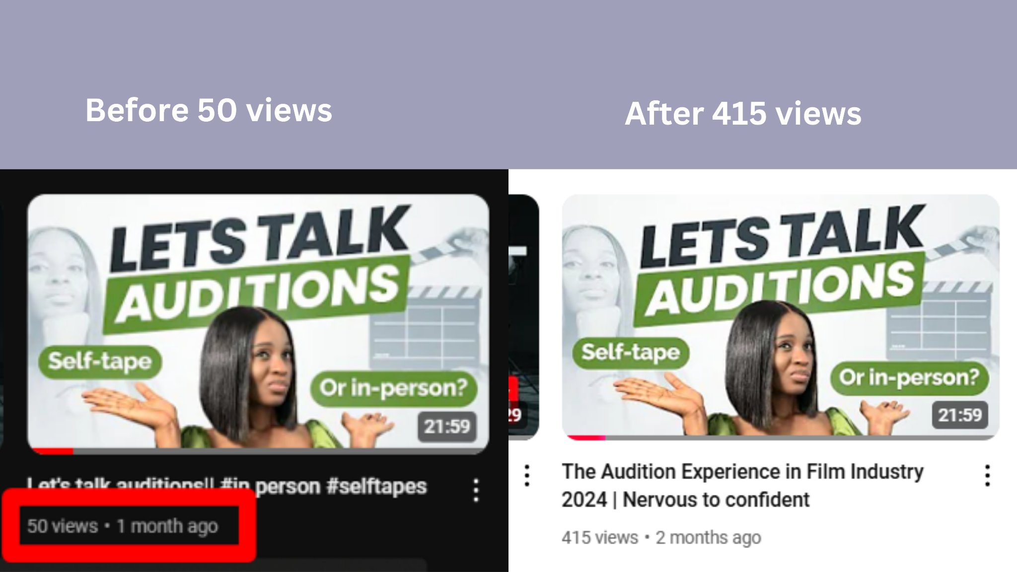

**9.** List of Items Every Actor Must Have | Actor toolkits in Film industry

**Before SEO Score :**

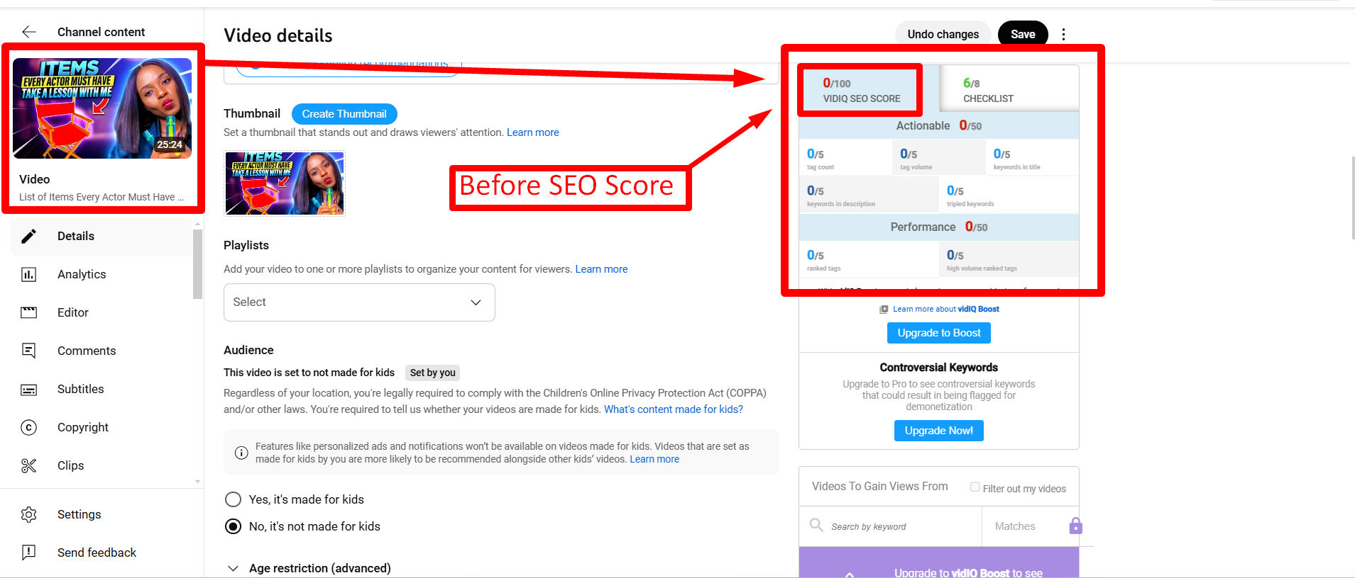

**After SEO Score :**

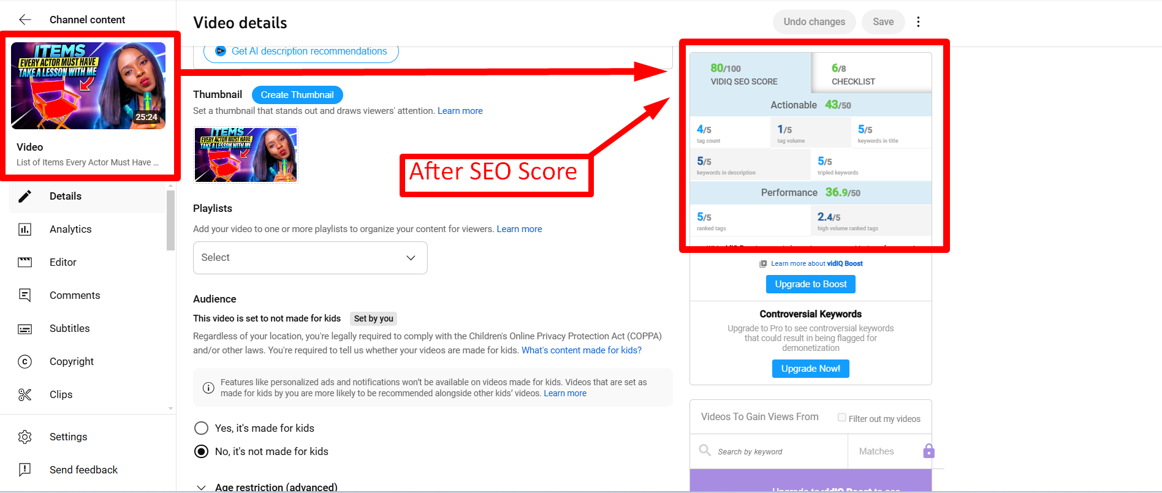

**10.** Dealing with insecurities in Film Industry | Tips for Overcoming Insecurities

**Before SEO Score :**

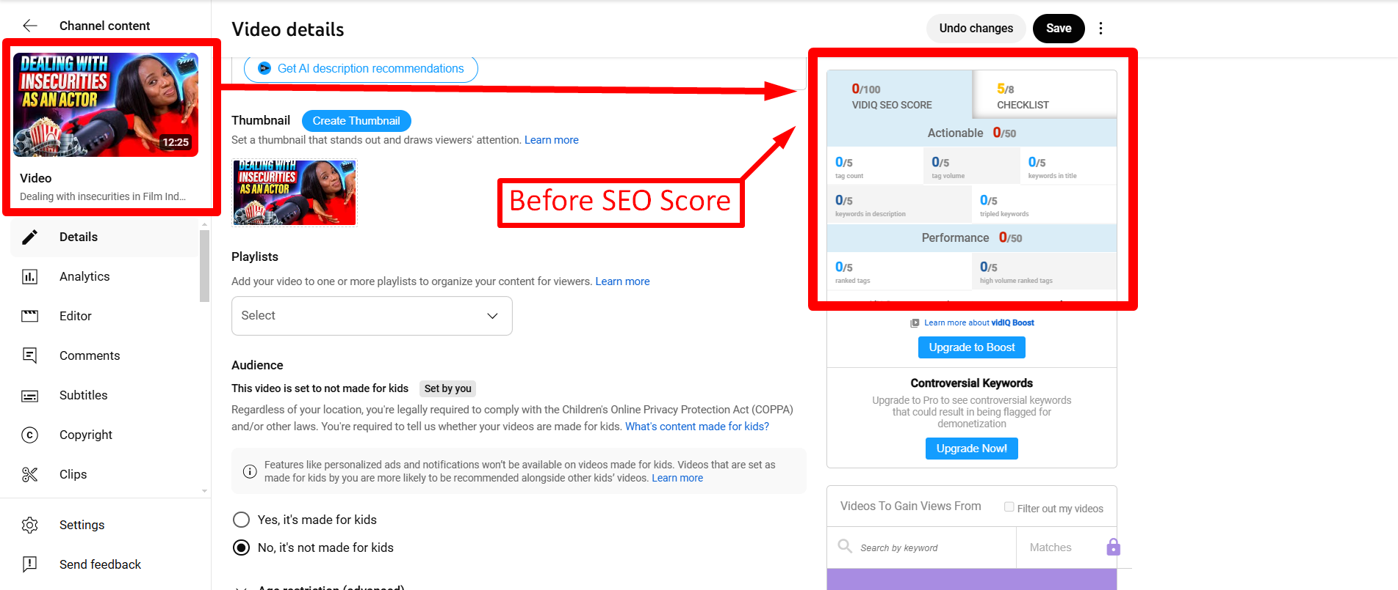

**After SEO Score :**

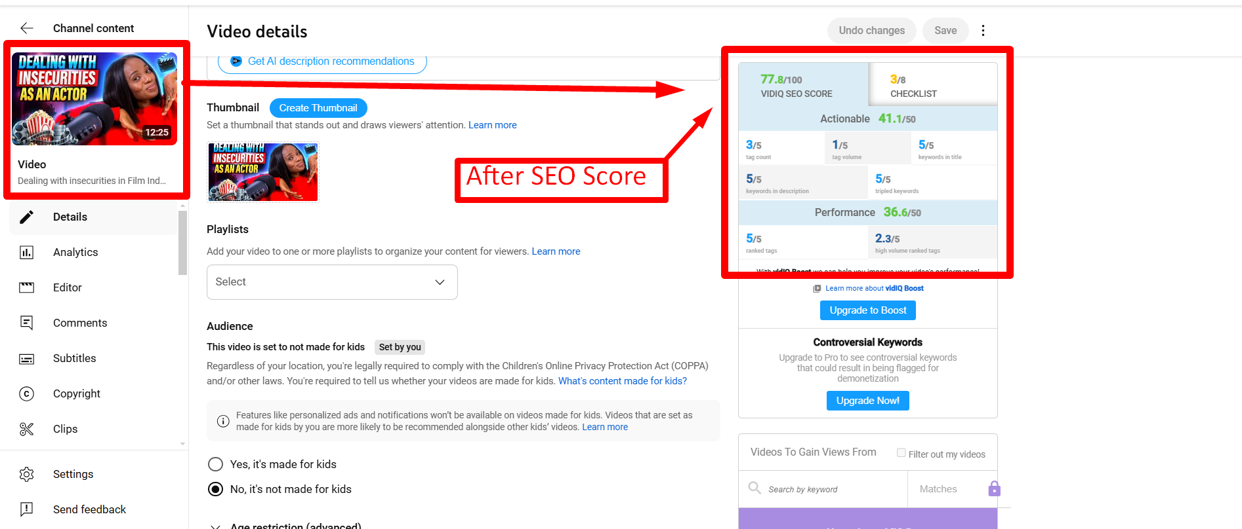

**11.** Actor tips to shine in film | Navigating Challenges in the Film Industry

**Before SEO Score :**

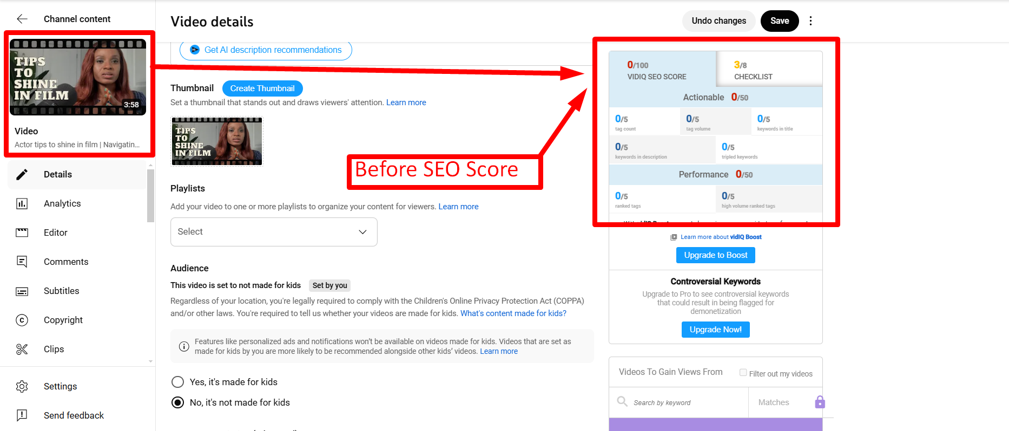

**After SEO Score :**

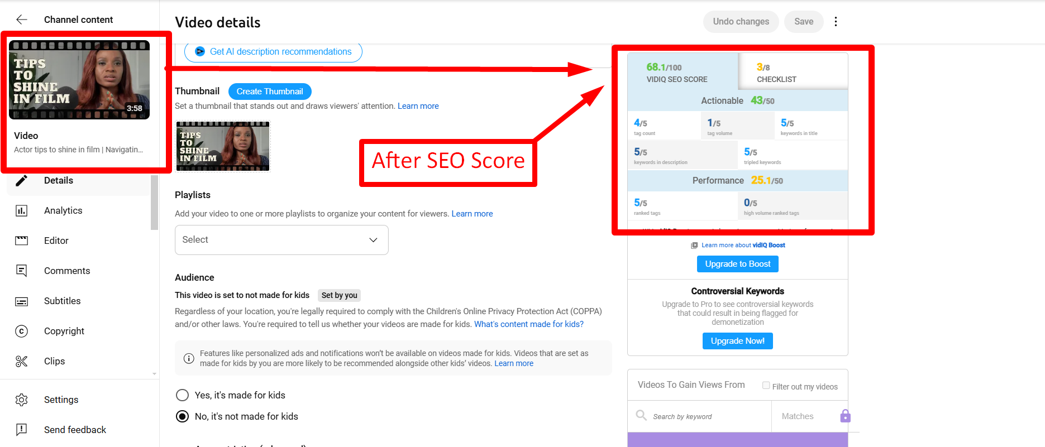

**Youtube Search List of your video title :**

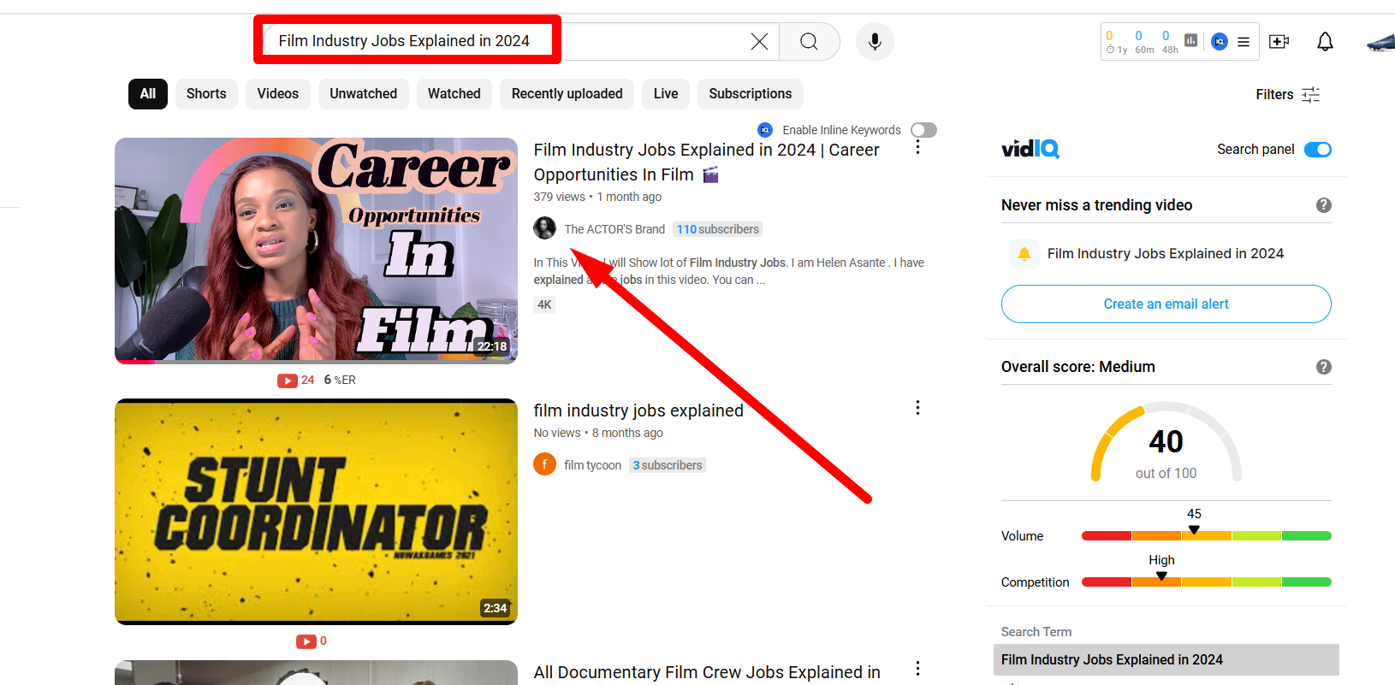

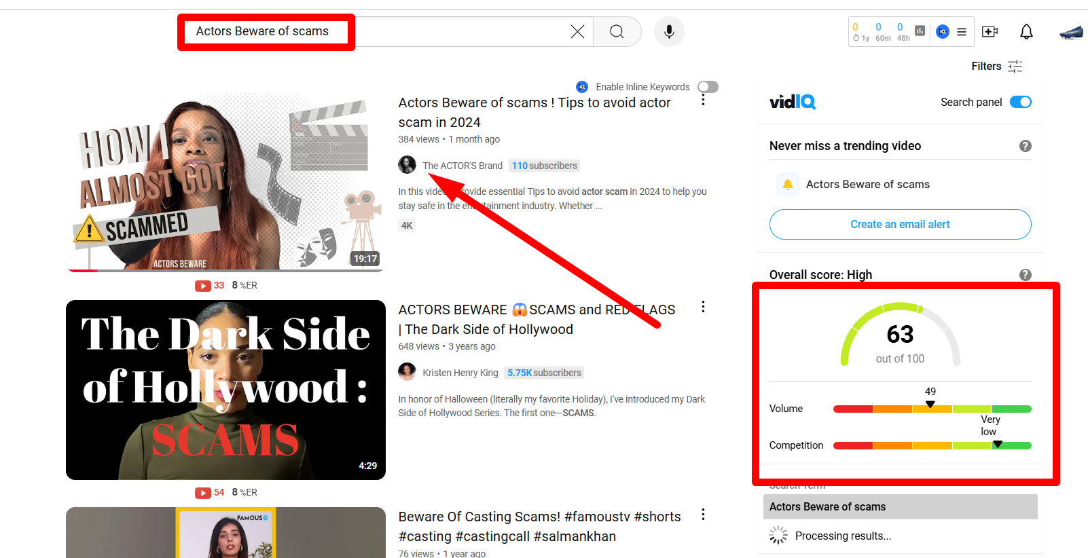

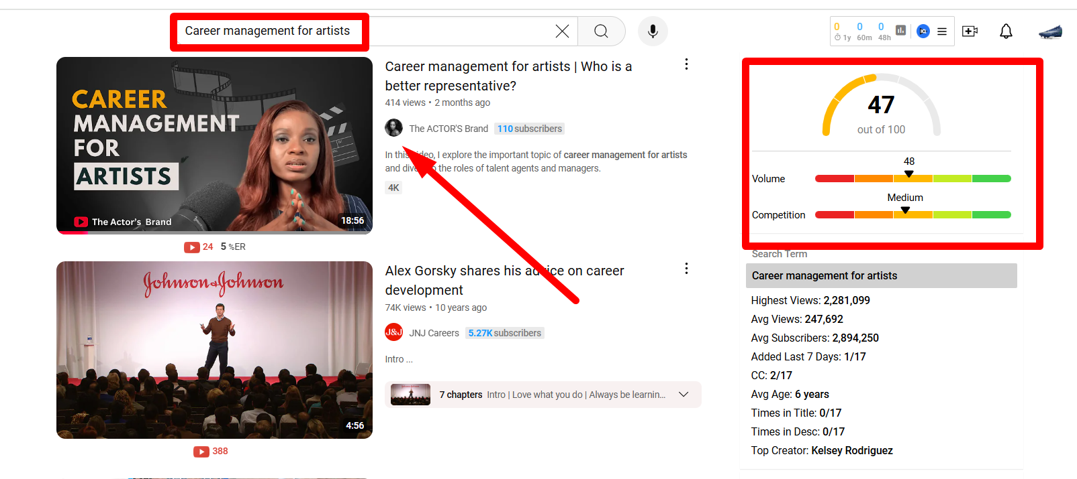

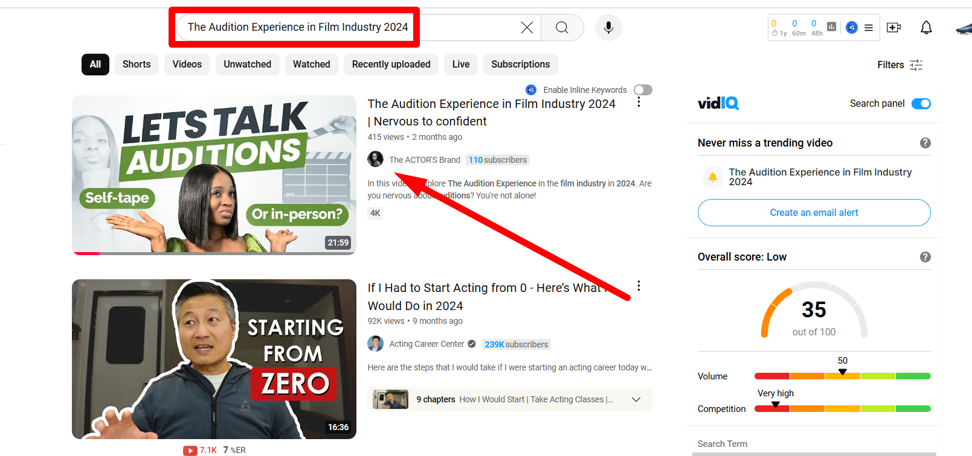

**Look at The Analytics Report Before and After work:**

**Before Analytics Report**

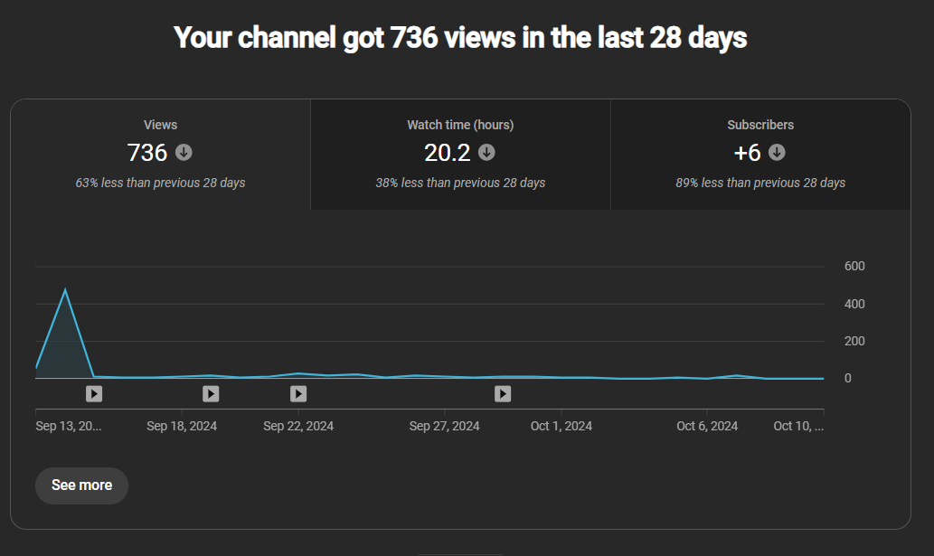

**After work, the Analytics Report**

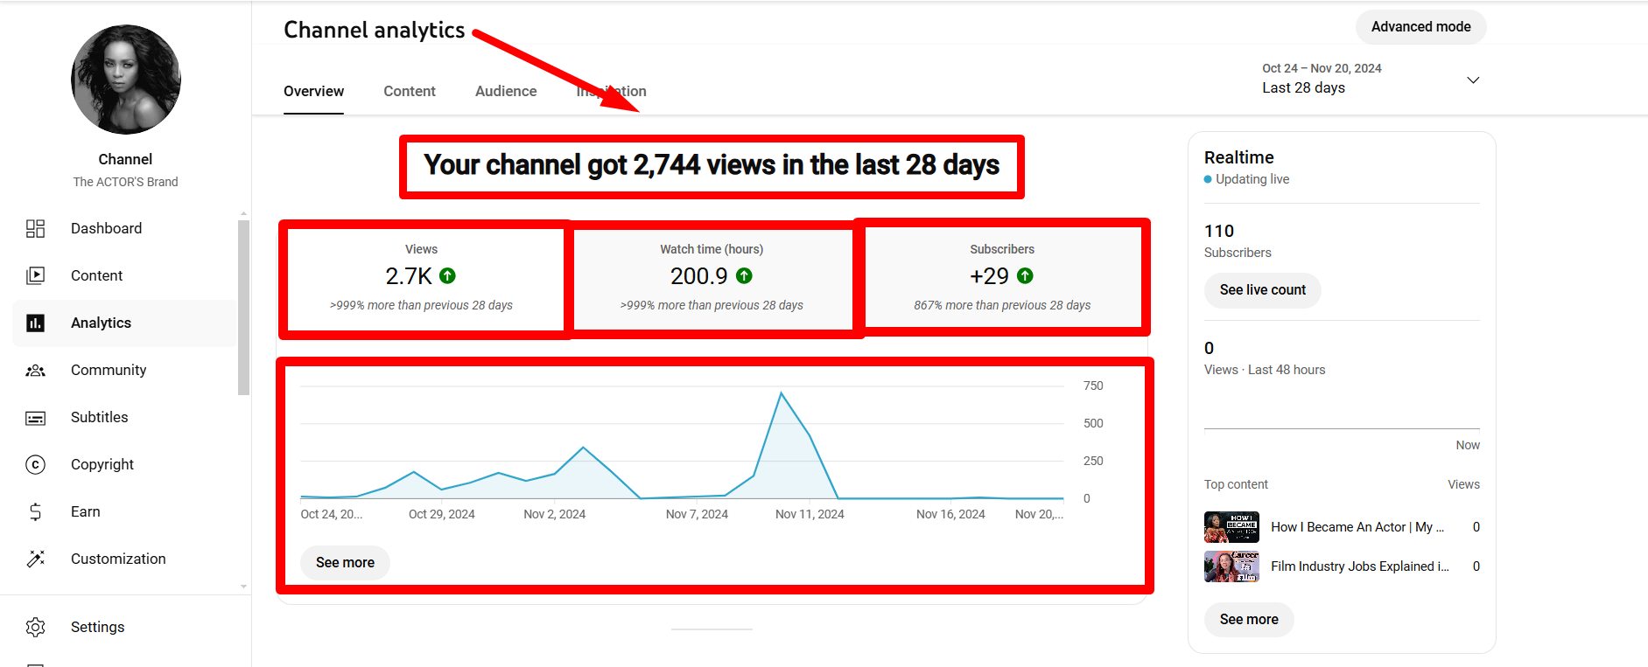

**Before**

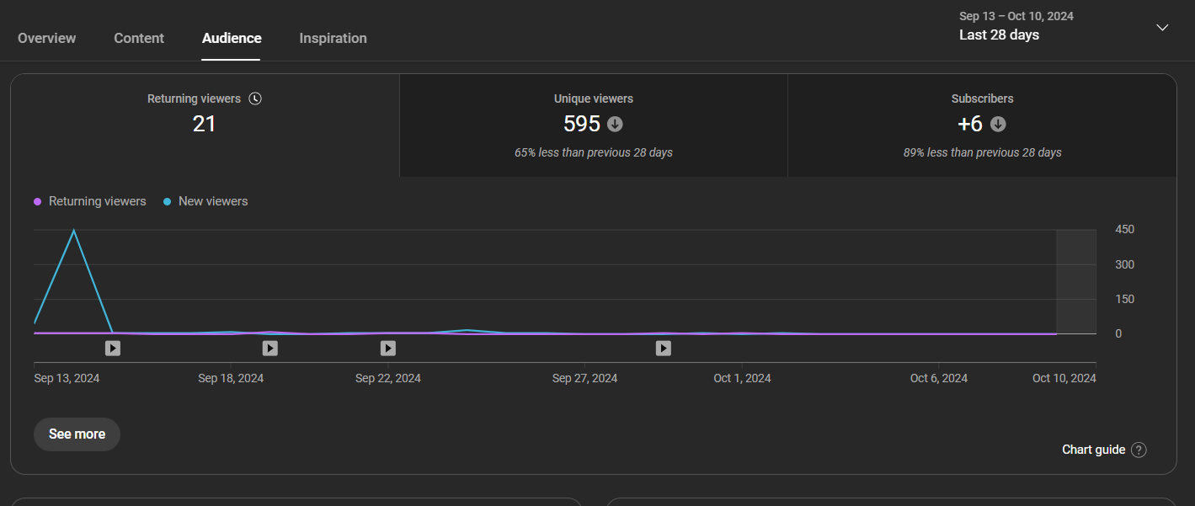

After

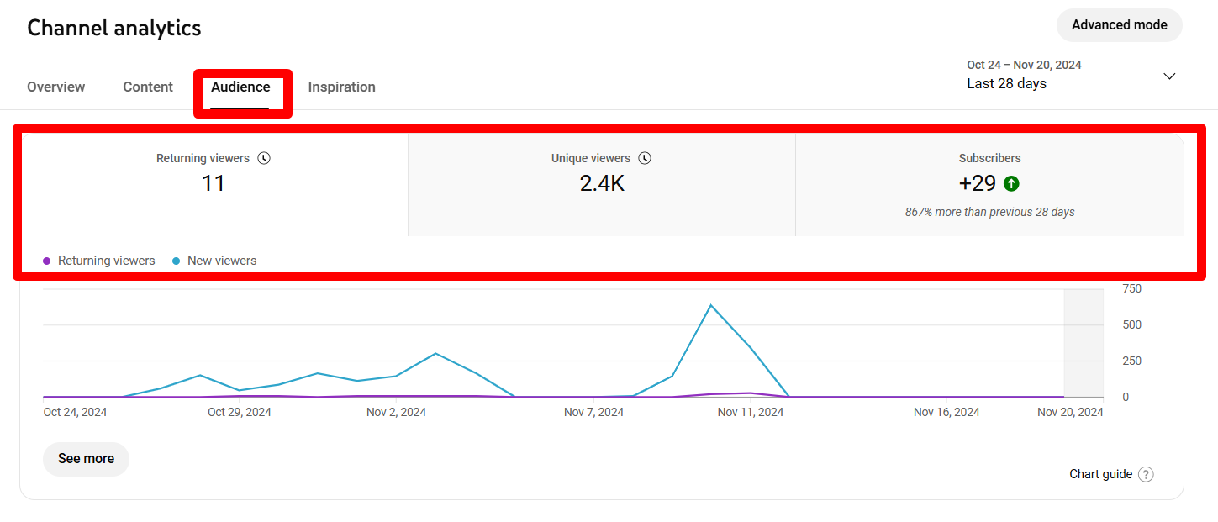

**Top Geography :**

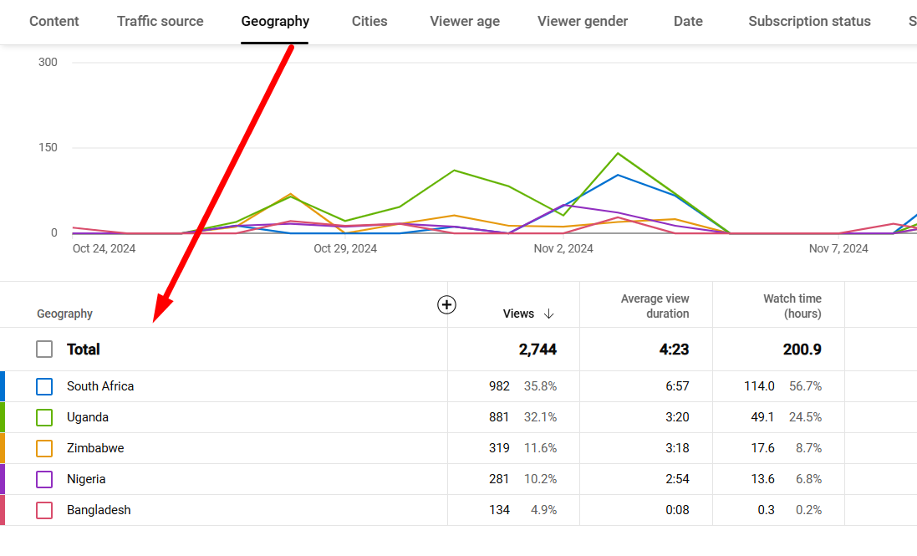

**Thank You**